# Object Oriented Programmings

LAB ASSIGNMENTS

**Priyank Lohariwal**

**BCSE-II (A2)  
001710501055**

Index

1. C++ code

Code………………………………………………………………….4

Output……………………………………………………………….6

1. Java code

Code…………………………………………………………………7

Output………………………………………………………………8

**Design a class for the following scenario:**

* **An item list contains item code, name, rate, and quantity for several items.**
* **Whenever a new item is added in the list uniqueness of item code is to be checked.**
* **Time to time rate of the items may change.**
* **Whenever an item is issued or received existence of the item is checked and quantity is updated.**
* **In case of issue, availability of quantity is also to be checked.**
* **User may also like to know price/quantity available for an item.**

#include<bits/stdc++.h>

using namespace std;

class item

//class to store basic details of an item

{

string code,name;

float price;

int quan;

public:

void get_item();

//function declaration for taking input in an item

void disp_item();

//function declaration to display an item details

void set_price(float pr);

//function declaration for setting the price of an item

string get_name()

//function definition to receive item name

{

return name;

}

string get_code()

//function to receive item code

{

return code;

}

float ret_price()

//function to return price of an item

{

return price;

}

int ret_qty()

//function to return quantity of an item

{

return quan;

}

void set_qty(int qty)

//function to set quantity of an item

{

quan=qty;

}

};

//

class itemlist

//class to store the item list available in the store

{

item l1[100];

//maximum 100 items can be stored in the list

int n_items;

public:

itemlist(int n=0)

//default constructor to receive the number of items in the list

{

n_items=n;

}

int get_num(int n)

//function to set number of items in the list

{

n_items=n;

}

int find_code(string temp)

//function to find item code of an item in the list and return the respective index

{

for(int i=0;i<n_items;i++)

{

if(temp.compare(l1[i].get_code())==0)

return i;

}

return -1;

}

void prepare_list();

//function declaration to prepare the list

void update_list();

//function declaration to update the list after a transaction

void disp_list();

//function decclaration to display the list

friend class orderline;

friend class order;

};

class orderline

//class to store the details of a particular order

{

string code;

int slno;

int quan;

public:

orderline()

{

quan=0;

slno=-1;

}

int get_item(itemlist&);

//function declaration to receive an order for an item

void ret_code(string,itemlist&);

//function declaration to return code of a particular item

int get_qty(itemlist&);

//function declaration to receive number of items for an order

int ret_qty()

//function to return quantity of an item in an order

{

return quan;

}

string get_code()

//function to return code of the item in the order

{

return code;

}

};

class order //class to store the details of a complete order

{

int n_items;

orderline list[10];

public:

order()

{

n_items=0;

}

void display_bill(itemlist&);

//function declaration to display bill of the order

void collect_order(itemlist &l1)

//function to collect order from the customer

{

l1.disp_list();

int chk;

cout<<"Enter the number of items you want to buy.\n";

cin>>n_items;

for(int i=0;i<n_items;i++)

{

chk=list[i].get_item(l1);

if(chk==-1)

{

i--;

cout<<"Enter again.\n";

}

}

}

void create_bill(itemlist&);

//function declaration to create the bill on the basis of the order

void update_list(itemlist&);

//function declaration to update the item list after a transaction

};

class Sales_interface

//class to manage the transactions for the shopkeeper

{

string pass="1234";

itemlist list1;

public:

void access_panel();

//function to maintain the access panel of the shopkeeper's system

void Admin();

//function for activities maintained by the admin

void User();

//function for activities for the user

};

//class item member function definitions

void item::get_item()

{

cout<<"CODE:";

cin>>code;

cout<<"NAME:";

cin>>name;

cout<<"QUANTITY:";

cin>>quan;

cout<<"PRICE:";

float pr;

cin>>pr;

set_price(pr);

}

void item::disp_item()

{

cout<<"Item code:"<<code<<endl;

cout<<"Item Name:"<<name<<endl;

cout<<"Price:"<<price<<endl;

}

void item::set_price(float pr)

{

price=pr;

}

//class itemlist member function definitions

void itemlist::prepare_list()

{

int j=0;

for(int i=0;i<n_items;i++)

{

cout<<endl;

item temp;

cout<<"ITEM "<<i+1<<endl;

temp.get_item();

int k=find_code(temp.get_code());

if(k==-1) {l1[j]=temp;j++;}

else l1[k].set_qty(temp.ret_qty());

}

}

void itemlist::update_list()

{

int ch,k,sl;

string s;

cout<<"1.Add an Item.\n2.Update existing stock.\n";

cin>>ch;

item temp;

switch(ch)

{

case 1:

temp.get_item();

k=find_code(temp.get_code());

if(k==-1) l1[n_items++]=temp;

else cout<<"Item already exists.\n";

break;

case 2:

cout<<"Enter the item_code to be updated:";

cin>>s;

sl=find_code(s);

if(sl==-1)

{

cout<<"Item does not exist\n";

return;

}

cout<<"Item Code:"<<l1[sl].get_code()<<endl;

cout<<"Item Name:"<<l1[sl].get_name()<<endl;

cout<<"Quantity:"<<l1[sl].ret_qty()<<endl;

cout<<"Price:"<<l1[sl].ret_price()<<endl;

cout<<"\nEnter new stock's quantity.";

int qn;

float pr;

cin>>qn;

l1[sl].set_qty(qn);

cout<<"Enter new price:";

cin>>pr;

l1[sl].set_price(pr);

break;

case 3: cout<<"Wrong choice!!!";

break;

}

}

void itemlist::disp_list()

{

cout<<"Sl.No.\tItem Code\tName\t\tQuan.\tPrice\n\n";

for(int i=0;i<n_items;i++)

{

cout<<i+1<<"\t"<<l1[i].get_code()<<'\t'<<'\t'<<l1[i].get_name()<<'\t'<<'\t'<<l1[i].ret_qty()<<'\t'<<l1[i].ret_price()<<endl;

}

}

//class orderline member function definitions

int orderline::get_item(itemlist& l1)

{

string nm;

cout<<"Enter the item:";

cin>>nm;

ret_code(nm,l1);

if(code.empty()){

cout<<"Item with that name does not exist!!\n";

return -1;

}

else

{

int q;

q=get_qty(l1);

if(q==-1){

cout<<"Not in Stock!!";

return -1;

}

else quan=q;

return 0;

}

}

void orderline::ret_code(string nm,itemlist& l1)

{

for(int i=0;i<l1.n_items;i++)

{

if(nm.compare(l1.l1[i].get_name())==0)

{

slno=i;

code= l1.l1[i].get_code();

}

}

return;

}

int orderline::get_qty(itemlist& l1)

{

int qn;

if(code.empty()) return 0;

cout<<"Enter quantity:";

cin>>qn;

if(l1.l1[slno].ret_qty() >= qn) return qn;

else return -1;

}

//class order member function definitions

void order::create_bill(itemlist &l1)

{

cout<<"Sl.No.\tItem Code\tName\tQuan.\tPrice\tAmount\n\n";

float amount[n_items];

for(int i=0;i<n_items;i++)

{

int n=l1.find_code(list[i].get_code());

amount[i]=l1.l1[n].ret_price()*list[i].ret_qty();

cout<<i+1<<"\t"<<list[i].get_code()<<'\t'<<'\t'<<l1.l1[n].get_name()<<'\t'<<list[i].ret_qty()<<'\t'<<l1.l1[n].ret_price()<<'\t'<<amount[i]<<endl;

}

cout<<"You want to purchase?[y/n]\n";

char c;

cin>>c;

if(c=='y') update_list(l1);

}

void order::display_bill(itemlist &l1)

{

cout<<"Sl.No.\tItem Code\tName\t\tQuan.\tPrice\tAmount\n\n";

float amount[n_items];

float sum=0;

for(int i=0;i<n_items;i++)

{

int n=l1.find_code(list[i].get_code());

amount[i]=l1.l1[n].ret_price()*list[i].ret_qty();

sum+=amount[i];

cout<<i+1<<"\t"<<list[i].get_code()<<'\t'<<'\t'<<l1.l1[n].get_name()<<'\t'<<'\t'<<list[i].ret_qty()<<'\t'<<l1.l1[n].ret_price()<<'\t'<<amount[i]<<endl;

}

cout<<endl<<"--------------------------------------------------\n\t\t\t\t\t\t\t\t\t\t\t\t\tTotal:\t\t"<<sum<<endl<<endl;

}

void order::update_list(itemlist &l1)

{

for(int i=0;i<n_items;i++)

{

int n=l1.find_code(list[i].get_code());

l1.l1[n].set_qty(l1.l1[n].ret_qty()-list[i].ret_qty());

}

}

//class Sales_interface member function definitions

void Sales_interface::Admin()

{

int choice;

char ch;

int x=0;

while(1)

{

cout<<"\n1.Prepare the list.\n2.Update the list.\n3.See the list.\n4.Exit.\n";

cin>>choice;

switch(choice)

{

case 1:

cout<<"Caution!!Doing this will remove the previously stored list.\nDo you want to continue?[y/n]";

cin>>ch;

if(ch=='n') break;

cout<<"\nEnter the number of items to be in the list:";

cin>>x;

list1.get_num(x);

list1.prepare_list();

break;

case 2:

list1.update_list();

break;

case 3:

list1.disp_list();

break;

case 4:

return;

}

}

}

void Sales_interface::User()

{

char ch='y';

while(ch=='y')

{

order o;

o.collect_order(list1);

o.create_bill(list1);

ch='n';

o.display_bill(list1);

cout<<"Want to order again?[y/n]";

cin>>ch;

}

}

void Sales_interface::access_panel()

{

int choice;

string pswd;

while(1)

{

cout<<"Enter the mode of access.\n\n1.Admin.\n2.User.\n3.Exit\n";

cin>>choice;

switch(choice)

{

case 1:

cout<<"Enter the password:";

cin>>pswd;

if(pswd.compare(pass)==0)

Admin();

else cout<<"Wrong Password!!!\n\n";

break;

case 2:

User();

break;

case 3:

return;

}

}

}

int main() //main function begins here

{

Sales_interface s1;

s1.access_panel();

return 0;}

Output

2.Bisection Method

#include<stdio.h>

#include<math.h>

float func(float x) //function to find the value of f(x)

{

float res;

res= exp(-x)-x;

return res;

}

int main(void) //main begins

{

FILE *fp;

fp=fopen("2.txt","w"); //file opens

int iter=1;

float a=-1.0,b=1.0,m,f_a,f_b,f_m,abs_error,multi;

fprintf(fp,"SL.no\t\ta\t\t\tb\t\t\tm\t\t\tf(m)\terror\n");

do //loop for finding the root of the function

{ abs_error=fabs(b-a);

m=(a+b)/2;

f_a=func(a); //calling the function

f_b=func(b);

f_m=func(m);

multi=f_m*f_a;

fprintf(fp,"%d\t\t%f\t%f\t%f\t%f\t%f\n",iter,a,b,m,f_m,multi,abs_error);

if(fabs(f_m)<=0.000005) //checking for required precision

break;

else if(multi<0) b=m;

else a=m;

iter++;

}while(fabs(b-a)>=0.000005); //checking for minimal error

fprintf(fp,"\n\nroot of the function = %f",m); //printing result in file

fclose(fp);

printf("res = %f",m); //printing result in terminal

}

Output

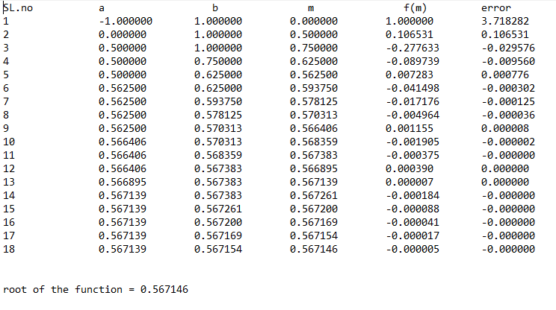

3.Chebysev’s Method

/*Program for describing chebysev method

f(x)= x^3-x-3*/

#include<stdio.h>

#include<math.h>

float func(float x) //function for finding the value of f(x)

{

return (x*x*x-x-3);

}

float dif_func(float x) //function for finding the value of f'(x)

{

return (3*x*x -1);

}

float dDifFunc(float x) //function for finding the value of f"(x)

{

return (6*x);

}

float ri(float r) //function for finding the value of r_next

{

return (r-(func(r)/dif_func(r))-(func(r)*func(r)*dDifFunc(r)/(2*dif_func(r)*dif_func(r)*dif_func(r))));

}

float gf(float x) //function for checking the convergence of the function

{

float res;

res=fabs(func(x)*dDifFunc(x)/((dif_func(x)*dif_func(x))));

return res;

}

int main() //main function begins here

{

int iter=1;

float r_i,r_i1,abs_error,prev_error=0,cond,conv;

printf("Enter the initial point:\n"); //input taken from user

scanf("%f",&r_i);

FILE *fp;

fp=fopen("3.txt","w"); //opening of file in write mode

fprintf(fp,"Sl.no.\t\tr \t\tcondition\t r_next\t\terror\torder of convergence\n");

do //loop for the method

{

cond=gf(r_i);

r_i1=ri(r_i); //updating the value of r_next

abs_error=fabs(r_i1-r_i);

if(prev_error!=0) conv=log(abs_error)/log(prev_error); //finding the order of convergence

prev_error=abs_error;

if(iter==1)

fprintf(fp,"%2d\t\t%9f\t%9f\t%9f\t%9f\t NA\n\n",iter,r_i,cond,r_i1,abs_error);

else

fprintf(fp,"%2d\t\t%9f\t%9f\t%9f\t%9f\t%9f\n\n",iter,r_i,cond,r_i1,abs_error,conv);

iter++;

r_i=r_i1;

}while(abs_error>=0.00001); //checking precision

printf("root of the function=%f\n",r_i1); //printing result

fprintf(fp,"root of the function=%f\n\n",r_i1);

fclose(fp);

return 0;

}

Output

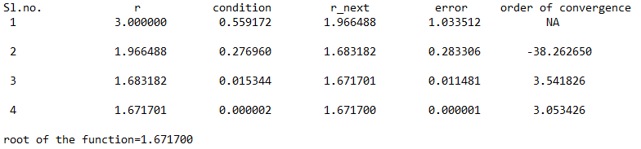

**4. Fixed Point Iteration**

/*Program to apply fixed point iteration*/

#include <stdio.h>

#include <math.h>

#define g(x) exp(-x)

#define dg(x) -exp(-x)

#define f(x) exp(-x)-x //original function f(x)=e^(-x)-x

double x1,e1;

int iter=0;

int main() //main begins

{

FILE *fp; //opening file pointer

fp=fopen("4.txt","w");

double x,order,e;

printf("Enter the starting point:");

scanf("%lf",&x); //taking initial input from the user

fprintf(fp,"SL\t\tx\t\tg(x)\t\tdg(x)\t\tf(x)\t\terror\t\torder\n");

do //loop to apply the method

{

iter++;

if (fabs(dg(x))>1) //checking for convergence

{

printf("the process may not converge to the root\n");

return 0;

}

x1=g(x);

e=fabs(x1-x);

if(iter==1)

fprintf(fp,"%d\t%9f\t%9f\t%9f\t%9f\t%9f\tNA\n",iter,x,g(x),dg(x),f(x),e,order);

else //finding order of convergence

{

order=log(e)/log(e1);

fprintf(fp,"%d\t%9f\t%9f\t%9f\t%9f\t%9f\t%9f\n",iter,x,g(x),dg(x),f(x),e,order);

}

e1=e;

x=x1;

}while(e>0.00005); //checking the precision

printf("The root of the equation is %f\n",x1); //printing final result

fprintf(fp,"\n\nThe root of the equation is %f\n",x1);

fclose(fp);

return 0;}

Output

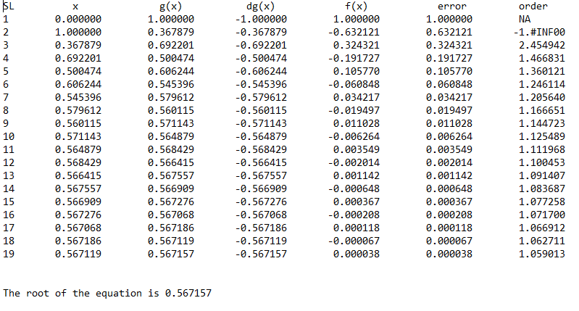

**5. Gauss Elimination Method**

/*Program to find the solution of linear equations using gauss elimination method*/

#include <stdio.h>

#include <stdlib.h>

#include <math.h>

void Gauss_Elimination(); //function prototype

int main(void)

{

Gauss_Elimination(); //calling function inside main function

}

void Gauss_Elimination()

{ int n,i,j,k,p; //variable decleration

FILE *fp;

fp=fopen("5.txt","w");

fprintf(fp," GAUSSIAN ELIMINATION FOR SOLVING LINEAR EQUATIONS.\n\n");

printf("Enter number of variables:");

scanf("%d",&n); //size of matrix

float a[n+1][n+2],m[n][n+2],sum,big,temp,x[n+1]; //variable decleration

big=0;

for(i=1;i<=n;i++){

x[i] = 0;

}

fprintf(fp,"Augmented matrix formed is:\n");

printf("Enter the augmented matrix.\n");

for(i=1;i<=n;i++){

for(j=1;j<=n+1;j++){

scanf("%f",&a[i][j]); //value giving for matrix

fprintf(fp,"%f\t",a[i][j]);

}

fprintf(fp,"\n");

}

for(k=1;k<n;k++)

{

big = 0;

for(i=k;i<n;i++) //partial pivoting

{

if(fabs(a[i][k])>big)

{

big = fabs(a[i][k]);

p = i;

}

}

for(j=k;j<=n+1;j++) //swapping values

{

temp = a[k][j];

a[k][j] = a[p][j];

a[p][j] = temp;

}

for(i = k+1;i<=n;i++)

{ //gauss elimination

m[i][k] = a[i][k] / a[k][k];

for(j=k;j<=n+1;j++)

{

a[i][j] = a[i][j] - m[i][k]*a[k][j];

}

}

}

for(i =n;i>=1;i--)

{

sum = 0;

for(j = n;j>=i;j--) //back substitution

{

sum = sum + a[i][j]*x[j];

}

x[i] = (a[i][n+1] -sum)/a[i][i]; //solving and finding values

}

for(i = 1;i<=n;i++)

{

printf("x%d = %f",i,x[i]); //print the result

fprintf(fp,"x%d = %f",i,x[i]);

printf("\n");

fprintf(fp,"\n");

}

for(i=1;i<=n;i++){

for(j=1;j<=n+1;j++){

printf("%f ",a[i][j]); //print the upper tringualr matrix after gauss elimination

fprintf(fp,"%f ",a[i][j]);

}

printf("\n");

fprintf(fp,"\n");

}

fclose(fp);

}

Output

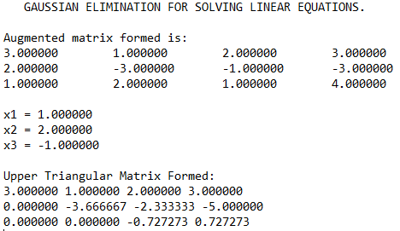

**6. Gauss Central Forward Difference Method**

/*

Program to implement GAUSS' FORWARD INTERPOLATION FORMULA.

---------------------------------

*/

#include<stdio.h>

#include<math.h>

void main()

{

FILE *fp;

fp=fopen("6.txt","w");

fprintf(fp,"GAUSS CENTRAL FORWARD INTERPOLATION.\n\n");

int n,i,j;

float y1,y2,y3,y4,x,nr,dr,y=0,h,p;

float diff[20][20];

// Input section.

printf("\n\n Enter the no. of terms: ");

scanf("%d",&n);

float ax[n],ay[n];

// Input Sequel for array X and Y

printf("\n\n Enter the value in the form of x f(x)\n ");

// Input loop for X and Y

for(i=0;i<n;i++)

scanf("%f%f",&ax[i],&ay[i]);

// Inputting the required value query

printf("\n\n Enter the required value of x.\n ");

scanf("%f",&x);

// Calculation and processing section.

h=ax[1]-ax[0];

for(i=0;i<n-1;i++)

diff[i][1]=ay[i+1]-ay[i];

for(j=2;j<=4;j++)

for(i=0;i<n-j;i++)

diff[i][j]=diff[i+1][j-1]-diff[i][j-1];

fprintf(fp,"x\t\t\tDifference Table\n");

for(i=0;i<n;i++) //difference table printed

{

fprintf(fp,"%f|\t",ax[i]);

fprintf(fp,"%f\t",ay[i]);

for(j=1;j<n-i;j++)

fprintf(fp,"%f\t",diff[i][j]);

fprintf(fp,"\n");

}

i=0;

//Implementation of the method performed here after

do

{

i++;

}while(ax[i]<x);

i--;

p=(x-ax[i])/h;

y1=p*diff[i][1];

y2=p*(p-1)*diff[i-1][2]/2;

y3=(p+1)*p*(p-1)*diff[i-2][3]/6;

y4=(p+1)*p*(p-1)*(p-2)*diff[i-3][4]/24;

// Taking sum

y=ay[i]+y1+y2+y3+y4;

// Outut Section

printf("\n When x = %6.4f , y = %6.8f\n",x,y);

fprintf(fp,"\n\nResult:\tf(%f)=%f",x,y); //final result printed in the file

fclose(fp);

}

Output

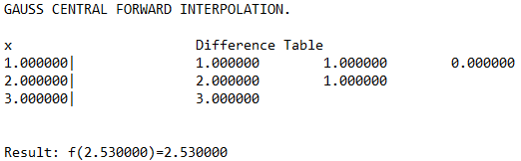

**7. Gauss Jordan Method**

/*Program to solve linear equations using gauss jordan method*/

#include<stdio.h>

#include<math.h>

void pivot(double a[100][100], int, int);

int main()

{

FILE *fp;

fp=fopen("7.txt","w");

int i,j,k,n,maxpos,l,ch,loop1,loop2;

double m,s,temp,max;

printf("Enter Value of n:\n"); //number of variables is scanned

scanf("%d", &n);

printf("Enter the augmented matrix:\n"); //augmented matrix is taken from the user

fprintf(fp,"The augmented matrix is:\n");

double a[n][n+1], x[n];

for(i=0; i<n; i++)

{

for(j=0; j<=n; j++){

scanf("%lf", &a[i][j]);

fprintf(fp,"%lf", &a[i][j]);

}

fprintf(fp,"\n");

}

for(k=0; k<n; k++) //loop for the implementation of the method

{

for(i=0; i<n; i++){

if(i==k)

continue;

m=a[i][k]/a[k][k];

for(j=k; j<n+1; j++)

a[i][j]= a[i][j]-(m*a[k][j]);

}

}

printf("\n");

fprintf(fp,"\n");

for(i=0; i<n; i++)

{

printf("\n");

fprintf(fp,"\n");

for(j=0; j<=n; j++)

{

printf("%lf ", a[i][j]);

fprintf(fp,"%lf ", a[i][j]);

}

}

for(i=0; i<n; i++)

{

x[i]=a[i][n]/a[i][i];

}

printf("\n\nSolution to the Equation:\n"); //printing the results

fprintf(fp,"\n\nSolution to the Equation:\n");

for(i=0; i<n; i++){

printf("%lf\n", x[i]);

fprintf(fp,"%lf\n",x[i]);

}

fclose(fp);

return 0;

}

Output

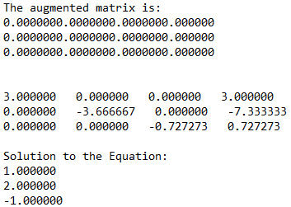

**8. Gauss Jordan Method(for finding inverse of a matrix)**

/*Program to find inverse of a given matrix*/

#include<stdio.h>

int main() //main begins here

{

FILE *fp;

fp=fopen("8.txt","w");

fprintf(fp," GAUSS JORDAN METHOD FOR FINDING INVERSE OF A MATRIX.\n\n");

int iter1, iter2, k, order;

printf("Enter order of matrix: ");

scanf("%d", &order); //taking the input for the oder of the matrix

float matrix[order][order*2], ratio,a;

printf("Enter the matrix: \n");

fprintf(fp,"The matrix is:\n\n");

for(iter1 = 0; iter1 < order; iter1++) //taking the input for the matrix

{

for(iter2 = 0; iter2 < order; iter2++)

{

scanf("%f", &matrix[iter1][iter2]);

fprintf(fp,"%f\t",matrix[iter1][iter2]);

}

fprintf(fp,"\n");

}

for(iter1 = 0; iter1 < order; iter1++) //making an identity matrix

{

for(iter2 = order; iter2 < 2*order; iter2++)

{

if(iter1==(iter2%order))

matrix[iter1][iter2] = 1.0;

else

matrix[iter1][iter2] = 0.0;

}

}

for(iter2=0; iter2<order; iter2++)

{

int temp=iter2;

/* finding maximum jth column element in last (dimension-j) rows */

for(iter1=iter2+1; iter1<order; iter1++)

if(matrix[iter1][iter2]>matrix[temp][iter2])

temp=iter1;

/* swapping row which has maximum jth column element */

if(temp!=iter2)

for(k=0; k<2*order; k++)

{

float temporary=matrix[iter2][k] ;

matrix[iter2][k]=matrix[temp][k] ;

matrix[temp][k]=temporary ;

}

/* performing row operations to form required identity matrix out of the input matrix */

for(iter1=0; iter1<order; iter1++)

if(iter1!=iter2)

{

ratio=matrix[iter1][iter2];

for(k=0; k<2*order; k++)

matrix[iter1][k]-=(matrix[iter2][k]/matrix[iter2][iter2])*ratio ;

}

else

{

ratio=matrix[iter1][iter2];

for(k=0; k<2*order; k++)

matrix[iter1][k]/=ratio ;

}

}

fprintf(fp,"\nThe inverse of the given matrix is:\n");

printf("The inverse matrix is: \n"); //printing the final result

for(iter1 = 0; iter1 < order; iter1++){

for(iter2 = order; iter2 < 2*order; iter2++)

{

printf("%f\t", matrix[iter1][iter2]);

fprintf(fp,"%f\t",matrix[iter1][iter2]);

}

printf("\n");

fprintf(fp,"\n");

}

fclose(fp);

return 0;

}

Output

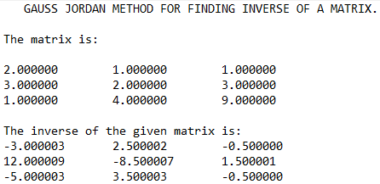

**9. Gauss Seidel Method**

/*Program for implementing Gauss seidel method*/

#include<stdio.h>

#include<math.h>

int main(void) //main begins here

{

FILE *fp;

fp=fopen("9.txt","w");

fprintf(fp," GAUSS SEIDEL METHOD.\n\n");

int order,i,j,k;

printf("Enter the number of variables\n");

scanf("%d",&order); //scans the number of variables

float A[order][order+1],x[order],x_new[order],error;

for(i=0;i<order;i++) //seeding the initial result

{

x[i]=0;x_new[i]=0;

}

printf("Enter the augmented matrix\n");

fprintf(fp,"The augmented matrix is:-\n");

for(i=0;i<order;i++){ //augmented matrix is scanned from the user row-wise

for(j=0;j<order+1;j++){

scanf("%f",&A[i][j]);

fprintf(fp,"%f\t",A[i][j]);

}fprintf(fp,"\n");

}

do //loop for implementing the method

{

for(i=0;i<order;i++)

{

x_new[i]=A[i][order]; //updating the value of x begins here

for(j=0;j<i;j++)

{

x_new[i]-=A[i][j]*x_new[j];

}

for(j=i+1;j<order;j++)

{

x_new[i]-=A[i][j]*x[j];

}

x_new[i]/=A[i][i];

}

error=fabs(x_new[0]-x[0]); //error calculation

for(i=0;i<order;i++)

{

if(error>fabs(x_new[i]-x[i])) error=fabs(x_new[i]-x[i]);

}

for(i=0;i<order;i++) x[i]=x_new[i];

}while(error>=0.00001); //minimum error calculation

printf("The solution set is:\n"); //printing the results

fprintf(fp,"The solution set is:\n");

for(i=0;i<order;i++){

printf("%0.5f\t",x[i]);

fprintf(fp,"%0.5f\t",x[i]);

}

printf("\n");

fclose(fp);

}

Output

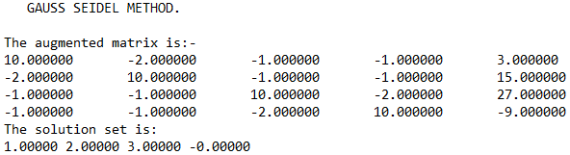

**10. Jacobi’s Method**

/*Program for implementing Jacobi's method*/

#include<stdio.h>

#include<stdlib.h>

#include<math.h>

int main(void) //main begins here

{

FILE *fp;

fp=fopen("10.txt","w");

fprintf(fp," JACOBI METHOD FOR SOLVING EQUATIONS.\n\n");

int order,i,j,k;

printf("Enter the number of variables\n");

scanf("%d",&order); //scans the number of variables

float A[order][order+1],x[order],x_new[order],error,max;

for(i=0;i<order;i++) //seeding the initial result

{

x[i]=0;x_new[i]=0;

}

printf("Enter the augmented matrix\n");

fprintf(fp,"The augmented matrix is:-\n");

for(i=0;i<order;i++){ //augmented matrix is scanned from the user row-wise

for(j=0;j<order+1;j++){

scanf("%f",&A[i][j]);

fprintf(fp,"%f\t",A[i][j]);

}fprintf(fp,"\n");

}

do //loop for implementing the method

{

for(i=0;i<order;i++)

{

x_new[i]=A[i][order]; //updating the value of x begins here

for(j=0;j<order;j++)

{

if(j!=i) x_new[i]-=A[i][j]*x[j];

}

x_new[i]/=A[i][i];

}

max=fabs(x_new[0]-x[0]); //error calculation

for(i=0;i<order;i++)

{

error=fabs(x_new[i]-x[i]);

if(error>max) max=error;

}

for(i=0;i<order;i++) x[i]=x_new[i];

}while(max>=0.000005); //minimum error calculation

printf("The solution set is:\n"); //printing the results

fprintf(fp,"The solution set is:\n");

for(i=0;i<order;i++){

printf("%0.5f\t",x[i]);

fprintf(fp,"%0.5f\t",x[i]);

}

printf("\n");

fclose(fp);

}

Output

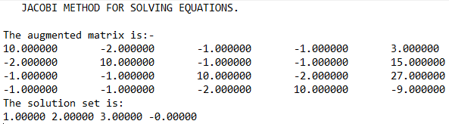

**11.** **Finding Eigen values of a matrix using Jacobi’s Method**

/*Program to find eigen value using jacobi's method*/

#include<stdio.h>

#include<math.h>

int main(void)

{

FILE *fp;

fp=fopen("11.txt","w");

fprintf(fp," Finding Eigen value using Jacobi's method\n\n");

int i,j,n,r,s;

printf("Enter the order of the matrix\n");

scanf("%d",&n);

float x[n][n],max=0,sum=0;

printf("Enter the symmetrix of order %d\n",n);

fprintf(fp,"The given matrix is:\n");

for(i=0;i<n;i++)

for(j=0;j<n;j++)

{

scanf("%f",&x[i][j]);

fprintf(fp,"%f\t",x[i][j]);

if(j>i)

{

sum+=x[i][j];

if(max<fabs(x[i][j]))

{

max=x[i][j];r=i;s=j;

}

}

fprintf(fp,"\n");

}

while(sum!=0)

{

float ang=atan((2*x[r][s])/(x[r][r]-x[s][s]))/2;

for(i=0;i<n;i++)

for(j=0;j<n;j++)

{

if(j>i && j!=r &&j!=s)

{

x[j][r]=x[j][r]*cos(ang)+x[j][s]*sin(ang);

x[r][j]=x[j][r];

x[j][s]=x[j][s]*cos(ang)-x[j][r]*sin(ang);

x[s][j]=x[j][s];

}

}

x[r][r]=x[r][r]*cos(ang)*cos(ang)+2*x[r][s]*cos(ang)*sin(ang)+x[s][s]*sin(ang)*sin(ang);

x[s][s]=x[s][s]*cos(ang)*cos(ang)-2*x[r][s]*cos(ang)*sin(ang)+x[r][r]*sin(ang)*sin(ang);

x[r][s]=0;x[s][r]=0;

max=0,sum=0;

for(i=0;i<n;i++)

for(j=0;j<n;j++)

{

if(j>i)

{

sum+=x[i][j];

if(max<fabs(x[i][j]))

{

max=x[i][j];r=i;s=j;

}

}

}

printf("%f\n",sum);

}

printf("The eigen values are:\n");

fprintf(fp,"The eigen values are:\n");

for(i=0;i<n;i++){

printf("%f\n",x[i][i]);

fprintf(fp,"%f\n",x[i][i]);}}

Output

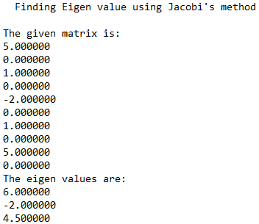

**12. Curve Fitting using Least Squares Method**

/*Program for applying least square method of curve fitting*/

#include<stdio.h>

#include<math.h>

int main() //main begins here

{

FILE *fp; //file pointer declared

fp=fopen("12.txt","w"); //file opened

fprintf(fp," Linear Curve fitting using least square method\n\n");

int n,i, x[20],y[20],sumx=0,sumy=0,sumxy=0,sumx2=0; //variables declared

float a,b;

printf("\n Enter the value of number of terms n:"); //scanning begins from here

scanf("%d",&n);

printf("\n Enter the values of x:\n");

for(i=0;i<=n-1;i++)

{

scanf(" %d",&x[i]);

}

printf("\n Enter the values of y:");

fprintf(fp,"Given inputs are:\n");

for(i=0;i<=n-1;i++)

{

scanf("%d",&y[i]);

fprintf(fp," f(%d)=%d\n",x[i],y[i]);

}

for(i=0;i<=n-1;i++) //calculation of the function

{

sumx=sumx +x[i];

sumx2=sumx2 +x[i]*x[i];

sumy=sumy +y[i];

sumxy=sumxy +x[i]*y[i];

}

a=((sumx2*sumy -sumx*sumxy)*1.0/(n*sumx2-sumx*sumx)*1.0); //final sum calculated

b=((n*sumxy-sumx*sumy)*1.0/(n*sumx2-sumx*sumx)*1.0);

printf("\n\nThe line is Y=%3.3fx +%3.3f \n",b,a); //final result being printed here

fprintf(fp,"\n\nThe line is Y=%3.3fx +%3.3f \n",b,a);

fclose(fp);

return 0;

}

Output

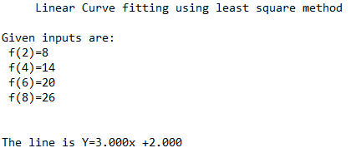

**13. LU Decomposition Method**

/*Program to implement LU decomposition method*/

#include<stdio.h>

int main(void) //main begins here

{

FILE *fp;

fp=fopen("13.txt","w");

fprintf(fp," LU Decomposition method.\n\n");

int size,i,j,p,k;

printf("Enter the order of the matrix.\n");

scanf("%d",&size); //size of the matrix scanned from the terminal

float A[size][size],L[size][size],U[size][size];

printf("Enter the matrix.\n"); //matrix is scanned

fprintf(fp,"A:");

for(i=0;i<size;i++){

for(j=0;j<size;j++){

scanf("%f",&A[i][j]);

fprintf(fp,"%f\t",A[i][j]);

}

fprintf(fp,"\n ");

}

for(i=0;i<size;i++) //matrices initialised

for(j=0;j<size;j++)

{

L[i][j]=0;U[i][j]=0;

}

for(j=0;j<size;j++) //loop of implementation

for(i=0;i<size;i++)

{

if(i>=j) //for lower matrix

{

L[i][j]=A[i][j];

for(k=0;k<=j-1;k++) L[i][j]-=L[i][k]*U[k][j];

if(i==j) U[i][j]=1;

}

else //for upper matrix

{

U[i][j]=A[i][j];

for(k=0;k<=i-1;k++)

U[i][j]-=L[i][k]*U[k][j];

U[i][j]/=L[i][i];

}

}

printf("\nL\n"); //printing results

fprintf(fp,"\nL:");

for(i=0;i<size;i++)

{

for(j=0;j<size;j++){

printf("%f\t",L[i][j]);

fprintf(fp,"%f\t",L[i][j]);

}

printf("\n");

fprintf(fp,"\n ");

}

printf("\nU\n");

fprintf(fp,"\nU:");

for(i=0;i<size;i++)

{

for(j=0;j<size;j++){

printf("%f\t",U[i][j]);

fprintf(fp,"%f\t",U[i][j]);

}

fprintf(fp,"\n ");

printf("\n");

}

fclose(fp);

}

Output

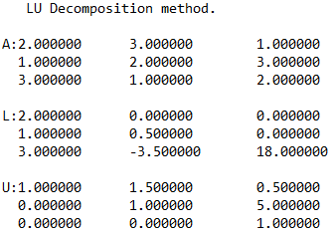

**14. Modified Euler’s Method**

a/*Program to apply modified euler's method for solving linear differential equation*/

#include<stdio.h>

#include<math.h>

#define fun(x,y) y-x //function used is y'=y-x

void main() //main begins here

{

FILE *fp;

fp=fopen("modified euler.txt","w");

fprintf(fp," Modified euler method for solving differential equation.\n\nDE: y'=y-x\n\n");

int i,j,c;

float x,y,h,m,m1,m2,a,s[100],w;

printf(" Enter the value of x0,xn,h,y0:\n"); //initial and final values of x, height of x and initial value of y is taken as input

scanf("%f%f%f%f",&x,&a,&h,&y);

s[0]=y;

printf(" The respective values of x and y are\n x \t y\n\n");

fprintf(fp," The respective values of x and y are\n x \t y\n\n");

for(i=1;x<a;i++) //method application here

{

printf(" %f\t%f\n",x,y);

fprintf(fp," %f\t%f\n",x,y);

w=100;

m=fun(x,y);

x= x+h;

c=0;

while(w>0.00001) //convergence of y at ith iteration

{

m1=fun(x,s[c]);

m2=(m+m1)/2;

s[c+1]=y+m2*h;

w=fabs(s[c]-s[c+1]);

c++;

}

y=s[c];

}

printf(" %f\t%f\n",x,y);

fprintf(fp," %f\t%f\n",x,y); //printing final results

fclose(fp);

}

Output

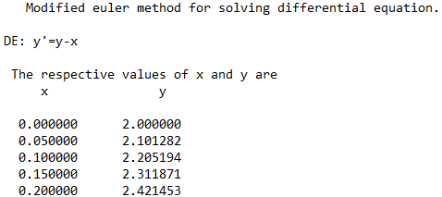

**15. Multi Point Iteration Method**

/*Program to apply multi point iteration method to find the root of the equation e^x-2x-1*/

#include<stdio.h>

#include<math.h>

double f(double x) //function to return f(x)

{

double y;

y=exp(x)-2*x-1;

return y;

}

double df(double x) //function to return f'(x)

{

double y;

y=exp(x)-2;

return y;

}

double soln(double r) //fuunction to return root of the equation using multipoint iteration method

{

int i=1;

double ri,ri_s,pre_err,err,order=0;

FILE *fp; //opening the file

fp=fopen("15.txt","w");

fprintf(fp," MULTI POINT ITERATION METHOD.\n\n");

pre_err=0;

err=0;

ri_s=r-(f(r)/(2*df(r))); //calculating ri+1*

ri=r-(f(r)/df(ri_s)); //calculating ri+1

pre_err=fabs(r-ri);

fprintf(fp,"i x f(x) a_error order");

fprintf(fp,"\n%d %lf %lf %lf %lf",i,r,f(r),pre_err,order);

while(fabs(r-ri)>=0.0001) //doing the iteration till error becomes less than 10^-4

{

r=ri;i++;

ri_s=r-(f(r)/(2*df(r))); //calculating ri+1*

ri=r-f(r)/df(ri_s); //calculating ri+1

err=fabs(r-ri); //calculating error

order=log(err)/log(pre_err); //calculating order of convergence

fprintf(fp,"\n%d %lf %lf %lf %lf",i,r,f(r),err,order);//printing results

pre_err=err; //updating previous error

}

fprintf(fp,"\n\nThe root of the equaion is %lf\n",r); //printing the final result

fclose(fp); //closing the file

return r; //returning the root

}

/*main begins here*/

void main()

{

double r;

printf("enter any starting point:"); //taking input from the user

scanf("%lf",&r);

printf("\nroot=%lf",soln(r)); //printing the result by calling the function

}

Output

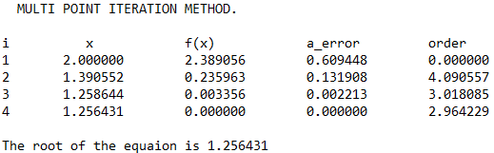

**16. Newton’s Backward Difference Interpolation Method**

/*Program to implement backward interpolation technique*/

#include<stdio.h>

#include<math.h>

int fact(int n) //function to find the factorial of n

{

int f=1,i;

for(i=2;i<=n;i++)

f*=i;

return f;

}

int main(void) //main begins

{

FILE *fp;

fp=fopen("16.txt","w"); //file opened to print the data in it

printf("Enter the number of inputs.\n");

int n,i,j;

scanf("%d",&n);

printf("Enter the values of the function as x,f(x)\n"); //inputs taken

float x[n];

float y[n][n];

for(i=0;i<n;i++)

scanf("%f%f",&x[i],&y[i][0]);

for(i=1;i<n;i++) //difference table created

for(j=n-1;j>=i;j--)

y[j][i]=y[j][i-1]-y[j-1][i-1];

fprintf(fp," x\t\t Difference table.\n");

for(i=0;i<n;i++) //difference table printed

{

fprintf(fp,"%f\t",x[i]);

for(j=0;j<=i;j++)

fprintf(fp,"%f\t",y[i][j]);

fprintf(fp,"\n");

}

float val; //interpolated value taken from the user

printf("Enter the value to interpolat at:(between %f and %f)\n",x[0],x[n-1]);

scanf("%f",&val);

float sum=y[n-1][0];

float u=(val-x[n-1])/(x[1]-x[0]); //height is found

float temp=u;

for(i=1;i<n;i++)

{

sum+=((u*y[n-1][i])/fact(i)); //formula of the technique implemented here

u*=(temp+i);

}

printf("Value at %f is %f\n",val,sum); //final result printed in the terminal and the file

fprintf(fp,"\n\n\nf(%f)=%f\n",val,sum);

}

Output

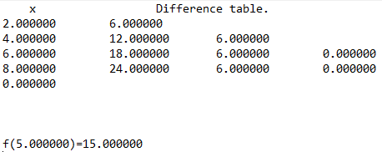

**17. Newton’s Forward Difference Interpolation Method**

/*Program to implement forward interpolation technique*/

#include<stdio.h>

#include<math.h>

int fact(int n) //function to find the factorial of n

{

int f=1,i;

for(i=2;i<=n;i++)

f*=i;

return f;

}

int main(void) //main begins

{

FILE *fp;

fp=fopen("17.txt","w"); //file opened to print the data in it

int n=4,i,j;

printf("Enter the values of the function as x,f(x)\n"); //inputs taken

float x[4];

float y[4][4];

for(i=0;i<4;i++)

scanf("%f%f",&x[i],&y[i][0]);

for(i=1;i<n;i++) //difference table created

for(j=0;j<n-i;j++)

y[j][i]=y[j+1][i-1]-y[j][i-1];

fprintf(fp," x\t\t f(x)\t\t df(x)\t\td1f(x) \td2f(x)\n");

for(i=0;i<n;i++) //difference table printed

{

fprintf(fp,"%f\t",x[i]);

for(j=0;j<n-i;j++)

fprintf(fp,"%f\t",y[i][j]);

fprintf(fp,"\n");

}

float val; //interpolated value taken from the user

printf("Enter the value to interpolat at:(between %f and %f)\n",x[0],x[3]);

scanf("%f",&val);

float sum=y[0][0];

float u=(val-x[0])/(x[1]-x[0]); //height is found

for(i=1;i<n;i++)

{

sum+=(u*y[0][i])/fact(i); //formula of the technique implemented here

u*=(u-1);

}

printf("Value at %f is %f\n",val,sum); //final result printed in the terminal and the file

fprintf(fp,"\n\n\nf(%f)=%f\n",val,sum);

}

Output

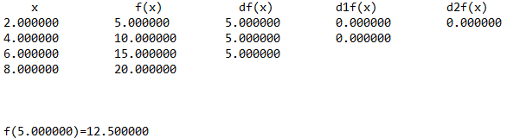

**18. Newton’ Forward Difference Formula for differentiation**

/*Program for applying newton forward difference formula for differentiation*/

#include<stdio.h>

#include<math.h>

int fact(int n) //function to find the factorial of n

{

int f=1,i;

for(i=2;i<=n;i++)

f*=i;

return f;

}

int main()

{

FILE *fp; //file pointer declared

fp=fopen("18.txt","w");

int n,i,j;

printf("Enter the number of terms.\n");

scanf("%d",&n);

float x[n],y[n][n]; //variables declared

for(i=0;i<n;i++) //inputs taken from the user

scanf("%f%f",&x[i],&y[i][0]);

for(i=1;i<n;i++) //difference table created

for(j=0;j<n-i;j++)

y[j][i]=y[j+1][i-1]-y[j][i-1];

fprintf(fp," x\t\t f(x)\t\t df(x)\t\td1f(x) \td2f(x)\n");

for(i=0;i<n;i++) //difference table printed

{

fprintf(fp,"%f\t",x[i]);

for(j=0;j<n-i;j++)

fprintf(fp,"%f\t",y[i][j]);

fprintf(fp,"\n");

}

float sum=0;

for(i=0;i<n-1;i++) //formula for the method

sum+=pow(-1,i)*y[0][i+1]/fact(i+1);

sum/=(x[1]-x[0]); //printing the final result

printf("The f'(%f) = %f\n",x[0],sum);

fprintf(fp,"\n\n\tThus, f'(%f) = %f\n",x[0],sum);

fclose(fp); //file pointer closed

}

Output

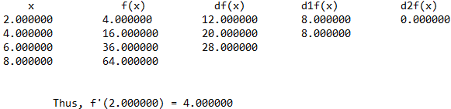

**19. Newton Raphson Method**

/*Program for describing newton raphson method

f(x)= x^3-x-3*/

#include<stdio.h>

#include<math.h>

float func(float x) //function for finding the value of f(x)

{

return (x*x*x-2*x-5);

}

float dif_func(float x) //function for finding the value of f'(x)

{

return (3*x*x -2);

}

float dDifFunc(float x) //function for finding the value of f"(x)

{

return (6*x);

}

float ri(float r) //function for finding the value of r_next

{

return (r-(func(r)/dif_func(r)));

}

float gf(float x) //function for checking the convergence of the function

{

float res;

res=fabs(func(x)*dDifFunc(x)/((dif_func(x)*dif_func(x))));

return res;

}

int main() //main function begins here

{

int iter=1;

float r_i,r_i1,abs_error,prev_error=0,cond,conv;

printf("Enter the initial point:\n"); //input taken from user

scanf("%f",&r_i);

FILE *fp;

fp=fopen("19.txt","a"); //opening of file in write mode

fprintf(fp," NEWTON RAPHSON METHOD\n\n");

fprintf(fp,"Sl.no.\tr\t\t\tcondition\tr_next\t\terror\t\torder of convergence\n");

do //loop for the method

{

cond=gf(r_i);

if(cond>1) //checking the divergency of the function

{

printf("function diverges!!\nProgram failed!!!!\n"); // if diverges,program fails

fprintf(fp,"Function diverges!!\n\n\n");fclose(fp);return 0;

break;

}

r_i1=ri(r_i); //updating the value of r_next

abs_error=fabs(r_i1-r_i);

if(prev_error!=0) conv=log(abs_error)/log(prev_error); //finding the order of convergence

prev_error=abs_error;

if(iter==1)

fprintf(fp,"%d\t\t%f\t%f\t%f\t%f\tNA\n\n",iter,r_i,cond,r_i1,abs_error);

else

fprintf(fp,"%d\t\t%f\t%f\t%f\t%f\t%f\n\n",iter,r_i,cond,r_i1,abs_error,conv);

iter++;

r_i=r_i1;

}while(abs_error>=0.00001); //checking precision

printf("root of the function=%f",r_i1); //printing result

fprintf(fp,"root of the function=%f",r_i1);

fclose(fp);

return 0;

}

Output

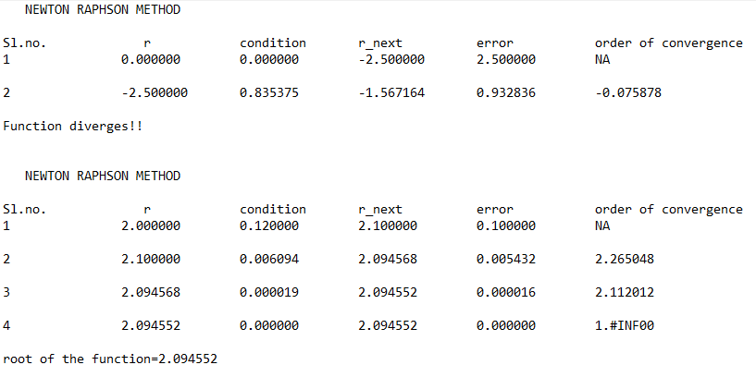

20. Newton Raphson method for solving non-linear simultaneous equations

/*Program to implement Newton raphson mathod for solving non linear simultaneous equations*/

#include<stdio.h>

#include<math.h>

#define f(x,y) x*x-y*y-3 //first equation as f(x,y)=0

#define g(x,y) x*x+y*y-13 //second equation as g(x,y)=0

#define max(x,y) x>y?x:y //max function

//main begins

int main(void)

{

FILE *fp;

fp=fopen("20.txt","w");

fprintf(fp," Newton Raphson method for solving non-linear simultaneous equations\n\n");

fprintf(fp,"Functions:\nf(x,y)=x^2-y^2-3\ng(x,y)=x^2+y^2-13\n\n");

int iter=0;

float x,y,h,k,pfx,pfy,pgx,pgy,f0,g0,jac;

x=sqrt(6.5); //initialisation of x,y for making g(x,y)=0;

y=x;

fprintf(fp,"Sl\t\th\t\t\tk\t\t x\t\t\ty\t\tjacobian term\n");

do

{

iter++; //for printing the iterations

f0=f(x,y); //function values

g0=g(x,y);

pfx=2*x; //partial derivatives of functions w.r.t variable

pfy=-2*y;

pgx=2*x;

pgy=2*y;

jac=pfx*pgy-pfy*pgx; //value of jacobian

/*h and k are approximation to the value of x and y calculated by solving the equations

h(pfx)+k(pfy)=f0 and

h(pgx)+k(pgy)=g0*/

h=(pfy*g0-pgy*f0)/(pfx*pgy-pfy*pgx); //extending limits of x

k=(pgx*f0-pfx*g0)/(pfx*pgy-pfy*pgx); //extending limits of y

x=x+h;

y=y+k;

fprintf(fp,"%d\t%f\t%f\t%f\t%f\t%f\n",iter,h,k,x,y,jac); //printing value of x and y in each iteration

}while((max(f(x,y),g(x,y))>=0.0005)&&jac!=0); //loop shall run till functions tend to 0

printf("Results:\nx=%f y=%f \n",x,y); //printing final results

fprintf(fp,"\n\nResults:\nx=%f y=%f",x,y);

fclose(fp);

}

Output

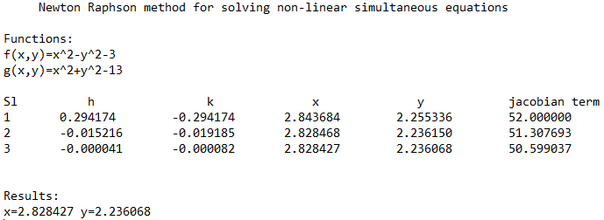

**21. Power Method**

//Program to find the eigen value of a given matrix

#include <stdio.h>

#include <math.h>

int main()

{

FILE *fp;

int i,j,order,iter=0;

printf("Enter the order of matrix:");

scanf("%d",&order); //scans the order of the matrix

fp=fopen("21.txt","w");

float A[order][order],x[order],z[order],e[order],zmax,emax; //declaring variable

printf("Enter the matrix\n");

fprintf(fp,"The given matrix is\n");

for(i=0; i<order; i++) //scanning matrix

{

for(j=0; j<order; j++)

{

scanf("%f",&A[i][j]); //scannning elements

fprintf(fp,"%f\t",A[i][j]); //print matrix in file

}

fprintf(fp,"\n");

}

fprintf(fp,"\n\n");

for(i=0; i<order; i++) //initialising first column vector

{

x[i]=1;

}

fprintf(fp,"Sl.No\tX1\t\tx2\t\tx3\t\tC\t\terrorMax\n"); //print column headers

do

{

iter++; // iteration

for(i=0; i<order; i++) //matrix multiplication

{

z[i]=0;

for(j=0; j<order; j++)

{

z[i]=z[i]+A[i][j]*x[j];

}

}

zmax=fabs(z[0]); //calculating max value

for(i=1; i<order; i++)

{

if((fabs(z[i]))>zmax)

zmax=fabs(z[i]);

}

for(i=0; i<order; i++) //divide the column matrix by c

{

z[i]=z[i]/zmax;

}

for(i=0; i<order; i++) //calculate error

{

e[i]=0;

e[i]=fabs((fabs(z[i]))-(fabs(x[i])));

}

emax=e[0];

for(i=1; i<order; i++)

{

if(e[i]>emax)

emax=e[i];

}

fprintf(fp,"%d\t%9.6f\t%9.6f\t%9.6f\t%9.6f\t%9.6f\n",iter,x[0],x[1],x[2],zmax,emax);

//printing iterations in files

for(i=0; i<order; i++) //reinitialising matrix

{

x[i]=z[i];

}

}while(emax>0.0001);

printf("The required eigen value is %f\n\n",zmax);

printf("The required eigen vector is :\n");

fprintf(fp,"\nThe required eigen value is %f\n\n",zmax); //printing results

fprintf(fp,"The required eigen vector is :\n");

for(i=0; i<order; i++)

{

printf("%f\n",z[i]);

fprintf(fp,"%f\n",z[i]);

}

return 0;

fclose(fp);

}

Output

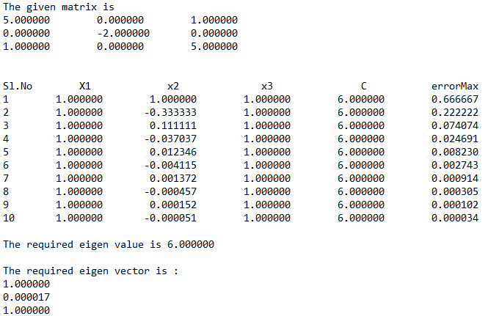

**22. Regula Falsi Method**

/*Program for implementing regula falsi method*/

#include<stdio.h>

#include<math.h>

float func(float x) //function to find the value of f(x)

{

float res;

res= exp(-x)-x;

return res;

}

int main(void) //main begins

{

FILE *fp;

fp=fopen("22.txt","w"); //file opens

int iter=1;

float a,b,c,f_a,f_b,f_c,abs_error,multi,prev_c,prev_error=0,conv;

do //taking input from user

{

printf("Enter lower and upper bound of x\n");

scanf("%f%f",&a,&b);

if(func(a)*func(b)>=0)

printf("ERROR!!! Enter again!\n");

}while(func(a)*func(b)>=0);

c=a; //for initialising a prev_c within range

fprintf(fp,"SL.no\t\ta\t\t\tb\t\t\tc\t\t\tf(c)\t\terror\torder of convergence\n");

do //loop for finding the root of the function

{

prev_c=c;

f_a=func(a); //calling the function

f_b=func(b);

c=((a*f_b)-(b*f_a))/(f_b-f_a);

f_c=func(c);

multi=f_c*f_a;

abs_error=fabs(prev_c-c);

if(prev_error!=0){

conv = log(abs_error)/log(prev_error);}

prev_error=abs_error;

fprintf(fp,"%d\t\t%f\t%f\t%f\t%f\t%f\t%f\n",iter,a,b,c,f_c,abs_error,conv);

if(fabs(f_c)<=0.000005) //checking for required precision

break;

else if(multi<0) b=c;

else a=c;

iter++;

}while(fabs(prev_c-c)>=0.000005); //checking for minimal error

fprintf(fp,"\n\nroot of the function = %f",c); //printing result in file

fclose(fp);

printf("res = %f",c); //printing result in terminal

}

Output

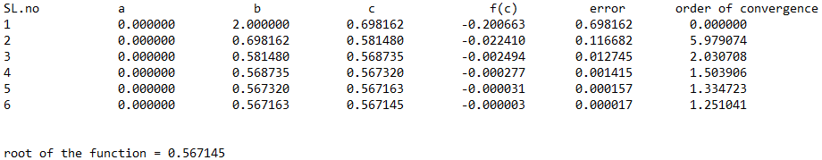

**23. Runge Kutta Method**

/*Program to apply runge kutta method for solving linear differential equations*/

#include<stdio.h>

#include<math.h>

#define f(x,y) y-x //function used :- y'=y-x

int main()

{

FILE *fp;

fp=fopen("23.txt","w"); //file opened in writing mode

fprintf(fp," Second Order runge kutta method for solving differential equation.\n\nDE: y'=y-x\n\n");

float x0,y0,m1,m2,m3,m4,m,y,x,h,xn;

printf("Enter the value of x0,xn,h,y0:\n");

//initial and final values of x, height of x and initial value of y are taken as input

scanf("%f %f %f %f",&x0,&xn,&h,&y0);

x=x0;

y=y0;

printf("\n\nX\t\tY\n");

fprintf(fp," The respective values of x and y are\n x \t y\n\n");

m=f(x0,y0)-h+h*f(x0,y0); //second orderr runga kutta formula

while(x<xn) //method application here

{

y=y+m*h;

x=x+h;

printf("%f\t%f\n",x,y);

fprintf(fp," %f\t%f\n",x,y); //printing final results at each iteration

}

}

Output

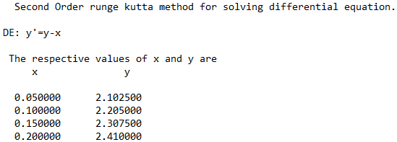

**24. Secant Method**

/*Program to apply secant method*/

#include<stdio.h>

#include<math.h>

#define f(x) exp(-x)-x //original function

int main() //main begins

{

FILE *fp;

fp= fopen("24.txt","w");

float x0,x1,x2,order,error,pre_error;

int iter=1;

fprintf(fp," SECANT METHOD\n\n");

printf("Solving Equation e^(-x)-x=0 using Secant method:\n");

printf("Please input initial approximations: ");

scanf("%f%f",&x0,&x1); //taking inputs from user

fprintf(fp,"Sl\t\tx0\t\t\tx1\t\t\tf(x0)\t\tf(x1)\t\tx2\t\t|x1-x0|\t\tOrder(c)\n");

do //method loop

{

x2=(x0*(f(x1))-x1*(f(x0)))/((f(x1))-(f(x0))); //formula to apply secant method

pre_error=fabs(x1-x0);

error=fabs(x2-x1);

order=log(error)/log(pre_error);

fprintf(fp,"%d\t%9f\t%9f\t%9f\t%9f\t%9f\t%9f\t%9f\n",iter,x0,x1,(f(x0)),(f(x1)),x2,fabs(x2-x1),fabs(order)); //printing results in the file

x0=x1;

x1=x2;

iter++;

}while(pre_error>0.0005); //condition for loop to end

fprintf(fp,"\n\nThe root of the equation is %f.\n",x1);

printf("\nThe root of the equation is: %f\n",x1); //printing final results

return 0;

fclose(fp);

}

Output

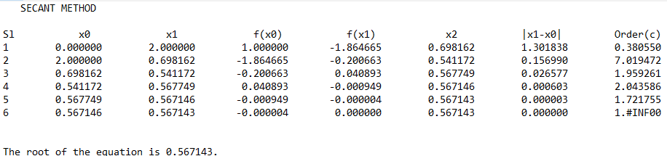

**25. Simpsons’ 1/3 Method**

/*Program to apply simpson's 1/3 method to solve a definite integrals*/

#include<stdio.h>

#include<math.h>

float f(float x) //function f=1/(1+x^2)

{

return 1/(1+x*x);

}

void main() //main begins here

{

FILE *fp;

fp=fopen("25.txt","w");

fprintf(fp," Simpson's method for solving definite integrals\n\nfunction used:- f(x)=1/(1+x^2)\n");

int i,n;

float x0,xn,h,y[20],sumo,sume,ans,x[20]; //variables declaration

printf("\n Enter values of x0,xn,h: "); //taking input for the limits of x

scanf("%f%f%f",&x0,&xn,&h);

n=(xn-x0)/h;

if(n%2==1) n++;

h=(xn-x0)/n;

printf("\n Y values: \n");

fprintf(fp,"\n Y values: \n");

for(i=0; i<=n; i++) //calculation of required values of x and y

{

x[i]=x0+i*h;

y[i]=f(x[i]);

printf("\n f(%f)=%f\n",x[i],y[i]);

fprintf(fp,"\n f(%f)=%f\n",x[i],y[i]);

}

sumo=0;

sume=0;

for(i=1; i<n; i++)

{

if(i%2==1) sumo+=y[i];

else sume+=y[i];

}

ans=h/3*(y[0]+y[n]+4*sumo+2*sume); //calculation of the final value

printf("\n Final integration is %f",ans);

fprintf(fp,"\n Final integration is %f",ans);

fclose(fp);

}

Output

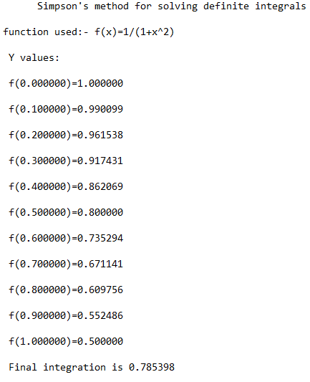

**26. Trapezoidal Method**

/*Program to integrate f(x)=1/(1+x^2) using trapezoidal rule*/

#include<stdio.h>

#include<math.h>

#define f(x) 1/(1+pow(x,2))

int main(void)

{

FILE *fp;

fp=fopen("26.txt","w");

fprintf(fp," Integrating f(x)=1/(1+x^2) using trapezoidal rule\n\n");

int i,n;

float x0,xn,h,sumo=0,sume=0,ans;

printf("\n Enter values of x0,xn,h(length of sub domain):\n");

scanf("%f%f%f",&x0,&xn,&h);

n=(xn-x0)/h;

if(n%2==1)

{

n=n+1;

}

h=(xn-x0)/n;

float x[n],y[n];

printf("\nrefined value of n and h are:%d %f\n",n,h);

printf("\n f(x) values \n"); //printing function values

fprintf(fp,"\n f(x) values \n");

for(i=0; i<=n; i++)

{

x[i]=x0+i*h;

y[i]=f(x[i]);

printf("\nf(%f)=%f\n",x[i],y[i]);

fprintf(fp,"\nf(%f)=%f\n",x[i],y[i]);

}

for(i=1; i<n; i++) //calculating integration sum

{

if(i%2==1)

{

sumo=sumo+y[i];

}

else

{

sume=sume+y[i];

}

}

ans=h/3*(y[0]+y[n]+4*sumo+2*sume); //calculating final integration sum

printf("\nfinal integration is %f",ans); //printing final result

fprintf(fp,"\n Final integration value is %f",ans);

fclose(fp);

}

Output

